Simulating the design in ModelSim
Quartus Prime 18.1

The goal of this intro is to simulate a half-adder circuit in ModelSim.
Checking the ModelSim path:
- Click Tools > Options.
- Under General, click EDA Tool Options.
- On your own computer:
  - Make sure that the “ModelSim-Altera” path is set. On your personal install, the path will likely be “C:\intelFPGA_lite\18.1\modelsim_ase\win32aloem
- On the lab computers:
  - Make sure that the “ModelSim” path is set. On the lab computers the path should be C:\modeltech64_2019.1\win64

Setting up ModelSim:
- Click Assignments > Settings
  - 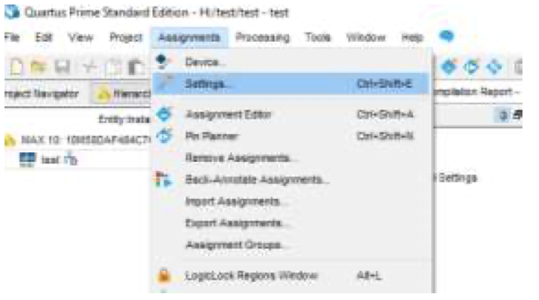
- On your own computer:
  - Navigate to EDA Tool Settings. Next to Simulation, under Tool Name, select ModelSim-Altera
- On the lab computers:
  - Navigate to EDA Tool Settings. Next to Simulation, under Tool Name, select ModelSim
- Click OK
Starting ModelSim:
- Click Tools > Run Simulation / Run Simulation Tool > RTL Simulation.
- Set the simulation language as VHDL.
- Once ModelSim starts, in the library window, expand the work library. You should see the halfadder.
  - 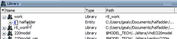
- Right-click on halfadder, click Simulate.
- In the transcript window, you can type Tcl commands (pronounced “tickle”). Use Enter/Return to execute each command.
  - 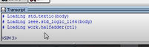
- Type the command “add wave *” then Enter. A waveform diagram should appear.
- Type the commands “force a 1”, “force b 0”, and “run 10”, pressing Enter after each command to execute. You should the see the waveform diagram update with these commands we forced. Right-click on the waveform window and select “zoom full” (or click on the waveform window and press “F”) to view the full simulation time (10 ps).
- Confirm that s = 1, representing the sum of a + b.
- Typing the commands quickly becomes tedious. We will now make a do file.
Creating a do file:
- Open a text editor.
- Type all the Tcl commands you want to execute in the do file. An example is below to get you started. You should add more commands to simulate all possible combinations of the inputs:
restart -f

force a 0
force b 0
run 10

force a 0
force b 1
run 10

- Save the file as “halfadder.do” in you project directory. Note that the file extension must be .do – to show file extensions on Windows, search “folder options” in settings, View > uncheck “Hide extensions for known file types”.
- Go back to ModelSim. In the transcript window, execute the Tcl command “do <filepath>” replacing <filepath> with the path to your .do file. A few notes:
  - If there is a space in the path, the file path must be in quotes. For example:
do “file path”
replacing file path is the full path to your .do file
  - All slashes in your file path must be / and not \.
  - Make sure your .do file has the extension .do, and is not a .txt file
  - If you still have trouble running the file, move it inside the simulation/modelsim folder in your project directory.
- You should now see your waveform diagram update. You may need to zoom out to see the full simulation time (right-click on the waveform window and select “Zoom Full” or click on the waveform window and press F).

Forcing a std_logic_vector:
Though not part of this tutorial, you will need to force values for vectors in the labs. To do this you need to specify the values of all bits in the vector, using one of the following methods:
- force <vector> b”<binary digits>”
  - <vector> is the name of your signal.
  - <binary digits> are the values of all digits in the signal
  - So for example, if we had a 3-bit vector named A that we want to force to 001 in binary, we would use the command
    - force A b”001”
  - You can also specify values in hexadecimal:
    - force A x”1”
- force <vector> <radix>#<value>
  - <vector> is the name of your signal.
  - <radix> is the base of <value>. Typically, this is 2, 8, 10, or 16.
  - <value> is the value you want to force.
  - So for example, if we had a 9-bit vector named select that we want to force to 673 in octal, we would use the command
    - force select 8#673

